  Curriculum vitae  Europass |  | Appendix no. 9
Personal information
Name / Surname |  | ALEXA TEODOR
Address(es) |  | PINULUI alley, no. 6, bl. P1, AP. 25,715200, DOROHOI, JUD. BOTOSANI, ROMANIA
Phone |  | Fix: |  |  |  |  | Mobil: |  | 0749368586
Fax |  | (optional column)
E-mail |  | teodoralexa026@gmail.com
Nationality |  | Romaniaa
Date of birth |  | 31.03.2008
Sex |  | Male
Desired employment / Occupational field |  | Student at Grigore Ghica Dorohoi National College
Professional experience |  | Class X
Period |  | 2025-2026
Occupation or position held |  | Mathematics computer science
Education and Training |  | Secondary education
Period |  | 2015-2025
Qualification / diploma obtained |  | Graduated 8 classes
The main subjects studied / professional skills acquired |  | Mathematics, informatics, English
Name and type of educational institution / training provider |  | "Mihail Kogalniceanu" Dorohoi Secondary School
Level in national or international classification |  | Secondary school
Personal skills and competences |  | Programming languages ​​(C#, C++, HTML, CSS, JS, LUA, PHP)
Foreign language(s) known |  | English
SELF |  |  | Understanding |  |  | Speaking |  |  |  | Writing
European level (*) |  |  | C1 |  | C1 | C1 |  | B2 |  | B2
Social skills and competences |  | Participation in the pedestrian camp.
Organisational skills and competences |  | Teamwork.
Technical skills and competences |  | Computer troubleshooting.
Computer skills and abilities |  | Techno-editing, programming, Unity, Microsoft Word, Visual Studio.
Artistic skills and competences |  | Drawing, Graphic Design, UI, UX,GUI.
Driver's license(s). |  | I don't own.

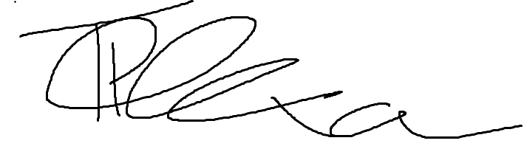

Signature Date 9/2/2024

